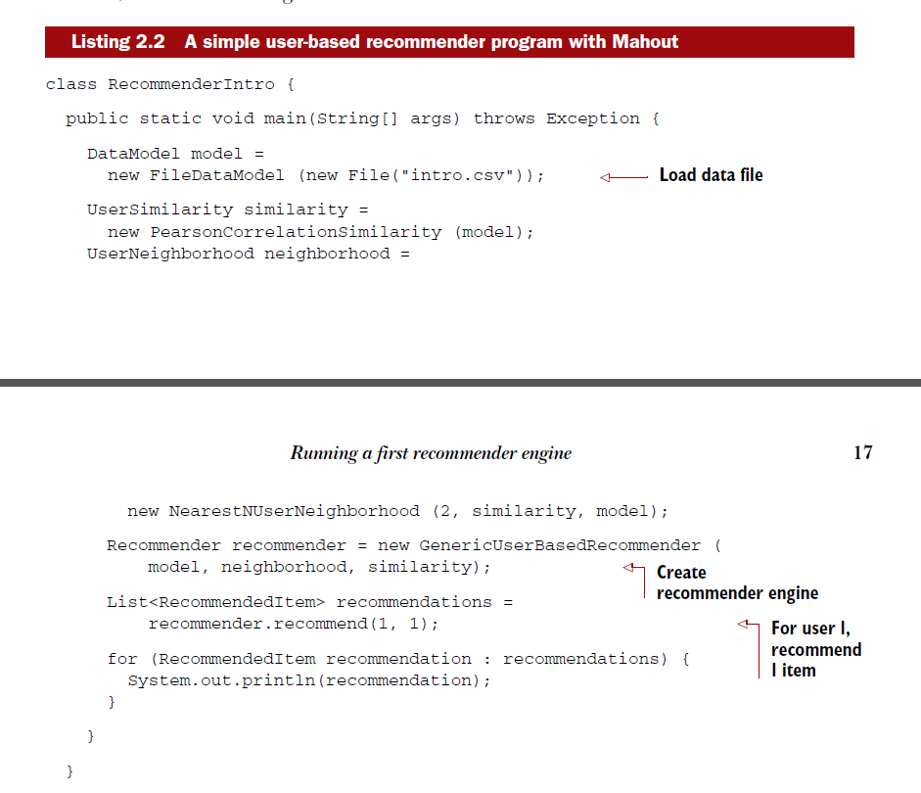

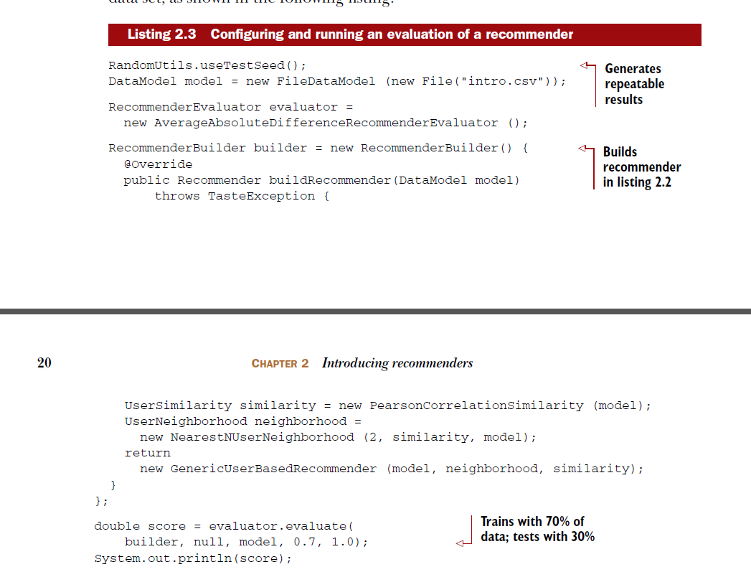

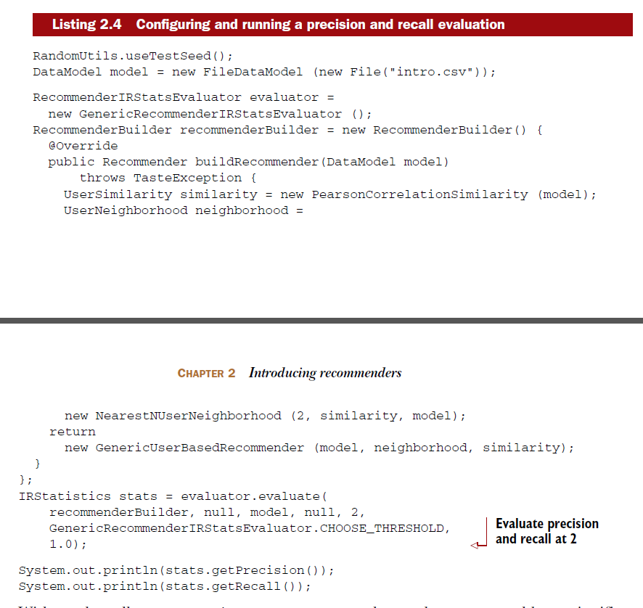

**precision is the proportion of top recommendations that are good recommendations, and recall is the proportion of good recommendations that appear in top recommendations.**

35：

Boolean preferences: like, dislike, nothing at all;(新闻，电影....)

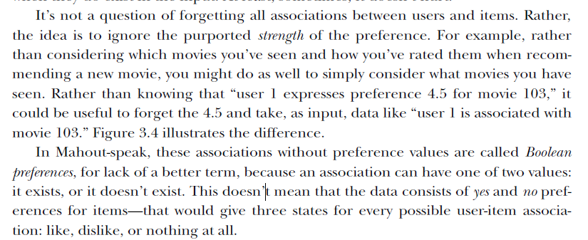

45:

